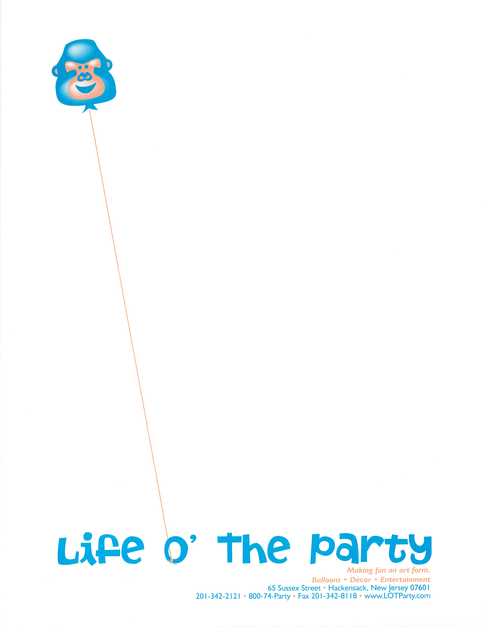
Making fun an art form.
Balloons • Décor • Entertainment
65 Sussex Street • Hackensack, New Jersey 07601
201-342-2121 • 800-74-Party • Fax 201-342-8118 • www.LOTParty.com
Mark Zettler, President
mark@lotparty.com

Casino Fundraiser Guidelines

Casino Fundraiser Guidelines

The most important thing to remember is to $$ make money $$. What you charge each guest is up to you and your organization. Make sure, at a minimum, to cover your costs then increase price per person so you are guaranteed to make a profit. The price per person should be based on your total cost divided by the number of people you are expecting. Whatever you charge above this cost would then be your profit.

Ways to alleviate costs:

Ad journals and table sponsorship.
Example: Find a local pizzeria, retail store or even a family who may want to sponsor a black jack table with a charge of $200. Then make a table sign showing who has sponsored the table. You can also give them free space in the ad journal if your organization is creating one. If you could get every table sponsored, that alleviates the casino cost and gives you that much more of a profit.

Other ways to make money are 50/50’s, silent auctions, and the selling of play money all throughout the event. Our manager at the event will also have “sales” on money bought at special times at each table.

Texas Hold ‘Em Tournament
Strategies for making profit:

Each guest is charged to be in tournament. Obviously, the amount you charge may vary. The cost for running the Texas Tournament can be offset in a couple of different ways. The most popular way is to have the tables sponsored. The other way to offset costs is selling space in an ad-journal.

Texas Hold ‘Em Software (mandatory for large tournaments) This special software displays all of the important statistics of the Tournament. Including: players seating chart, blinds, next blinds, time left for next blind increase, average chip count, number of players left and MUCH more.

Making fun an art form.
Balloons • Décor • Entertainment
65 Sussex Street • Hackensack, New Jersey 07601
201-342-2121 • 800-74-Party • Fax 201-342-8118 • www.LOTParty.com
Mark Zettler, President
mark@lotparty.com

Selling play money at the event:

We recommend at the door to give them $100 in play money with their ticket and or entry. This gives them either 20 minimum $5 bets. If you give them only $100 it increases your chances of selling more money at the event.
In the past, other fundraisers have done the following.
$20 real money equals $100 play money
$40 real money equals $200 play money
$50 real money equal $300 play money

The chip denominations are as follows:

Red chips $5.00
Green chips $25.00
Black chips $100.00 Play money only comes in $100 denomination.

Prizes and Prize Redemption:

There are only some items that cannot be given away as prizes (cash, firearms, & liquor etc.) You will have to call the LGCCC at 973-273-8000 to get the complete list of what cannot be auctioned.

Items that are acceptable: TV’s, CD or MP3 players, gift certificates (not redeemable for cash), gift baskets, sports memorabilia, theater tickets, etc. We recommend double sided raffle tickets for the redemption of prizes (we will provide). We also recommend the trade in value as follows: $100 play money for 1 double sided raffle ticket, this will keep the chaos of too many tickets down and hopefully increase the number of guests buying more play money in order to obtain more raffle tickets.

Important things to know:

1. A sit down dinner is NOT recommended. Pass around food is the best way to go.
2. The start time of the event should be at least 30 minutes prior to start of casino tables opening.
3. Make sure to have a cashier booth or area where guests can redeem chips and tickets.

Making fun an art form.
Balloons • Décor • Entertainment
65 Sussex Street • Hackensack, New Jersey 07601
201-342-2121 • 800-74-Party • Fax 201-342-8118 • www.LOTParty.com
Mark Zettler, President
mark@lotparty.com

License Procedure for a Casino Night

- The organization must be registered and hold a current registration certificate from the Legalized Games of Chance Control Commission (LGCCC) (note: there is an expiration date on the certificate, the event must take place before the certificate expires).
- The organization presents provider with a copy of the organization’ current registration certificate.
- The organization will receive a Form 13 from the provider.
- Take the original registration certificate and the Form 13 to the municipal clerk in the municipality in which the event will take place together with a check for $100 made out the municipality and $100 check made out to the Legalized Games of Chance Control Commission. A raffle license application will then be prepared.
- The municipality will conduct a police background check on the members of the organization listed on the application.
- The governing body of the municipality will vote to approve or disallow the application.
- If approved by the governing body, the application is sent by the municipal clerk to the LGCCC together with the $100 check.
- If the municipality is not contacted by the LGCCC within 14 days after mailing the application, the municipal clerk may issue the license.

PLEASE ALLOW PLENTY OF TIME FOR THIS PROCESS. Please be aware that because of the increasing numbers of organizations registering, the registration of a new organization may take 6-8weeks. The entire process takes time and there are no provisions in the law for shortcuts in the process.

After the event, the organization is also responsible for filing a report of operations by the 15th of the month following the event.

An application for registering an organization as well as other helpful information may be obtained from the LGCCC website at www.state.nj.us/lps/ca/lgccc.htm or by calling 973-273-8000

Casino Scenery - Las Vegas

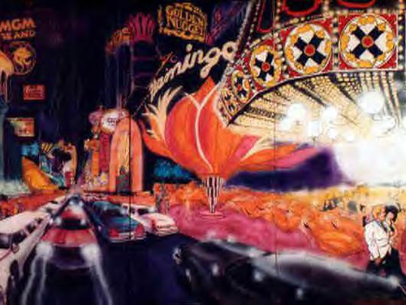

Black Jack Table

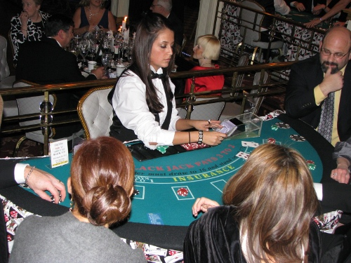

12’ Craps Table

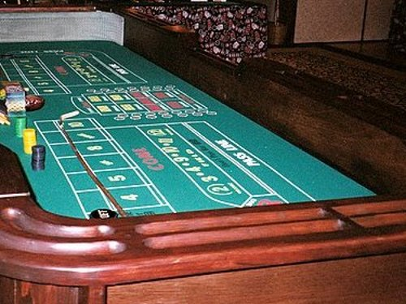

6’ Craps Table

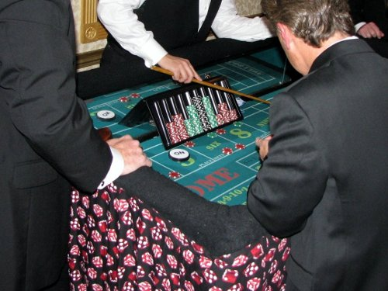

Texas Hold ‘Em Table

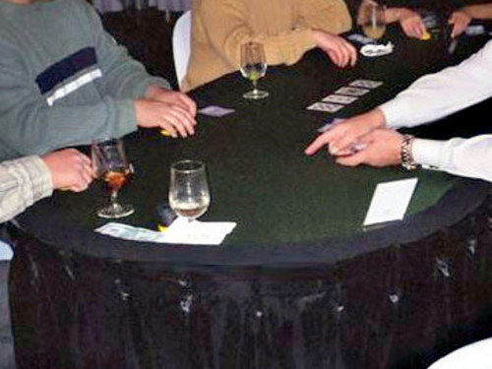

Money Wheel

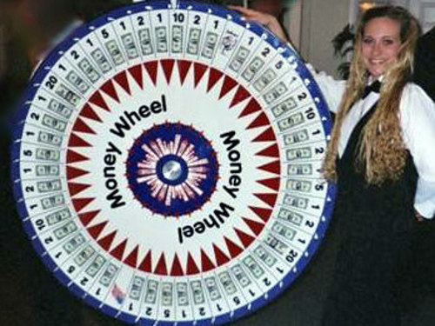
Red Dog

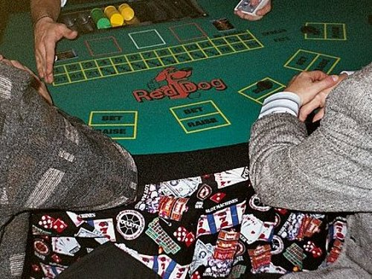

Texas Hold ‘Em Software
This special software displays all of the important statistics of the Tournament. Including: players seating chart, blinds, next blinds, time left for next blind increase, average chip count, number of players left and MUCH more. Includes a large video screen and technician
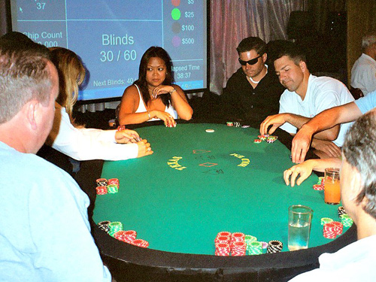
Raffle Drum

Cashier Booth

